**Practical No 1**

**Aim :**

1. Install NLTK
2. Convert the given text to speech
3. Convert audio file Speech to Text.

**Program**:

>pip install gtts

>pip install nltk

>pip install SpeechRecognition pydub

**b. Convert the given text to speech**

**Steps:**

1. create file.txt in respective folder.
2. Enter some message in file.txt.
3. Save texttospeech.py file at same location.

**Texttospeech.py**

from gtts import gTTS

import os

f = open('1.txt')

x=f.read()

langauge='en'

audio=gTTS(text=x,lang=langauge)

audio.save("wishes.wav")

os.system("wishes.wav")

print("program executed succesfully.")

**Output:**

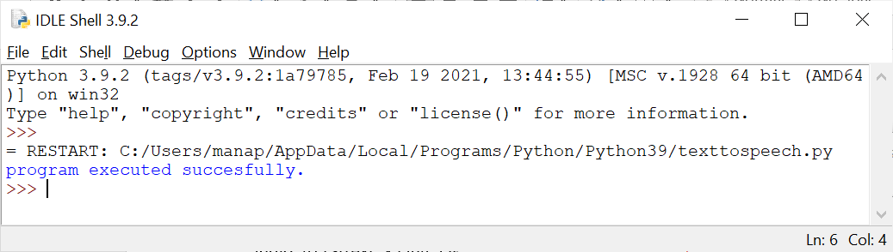

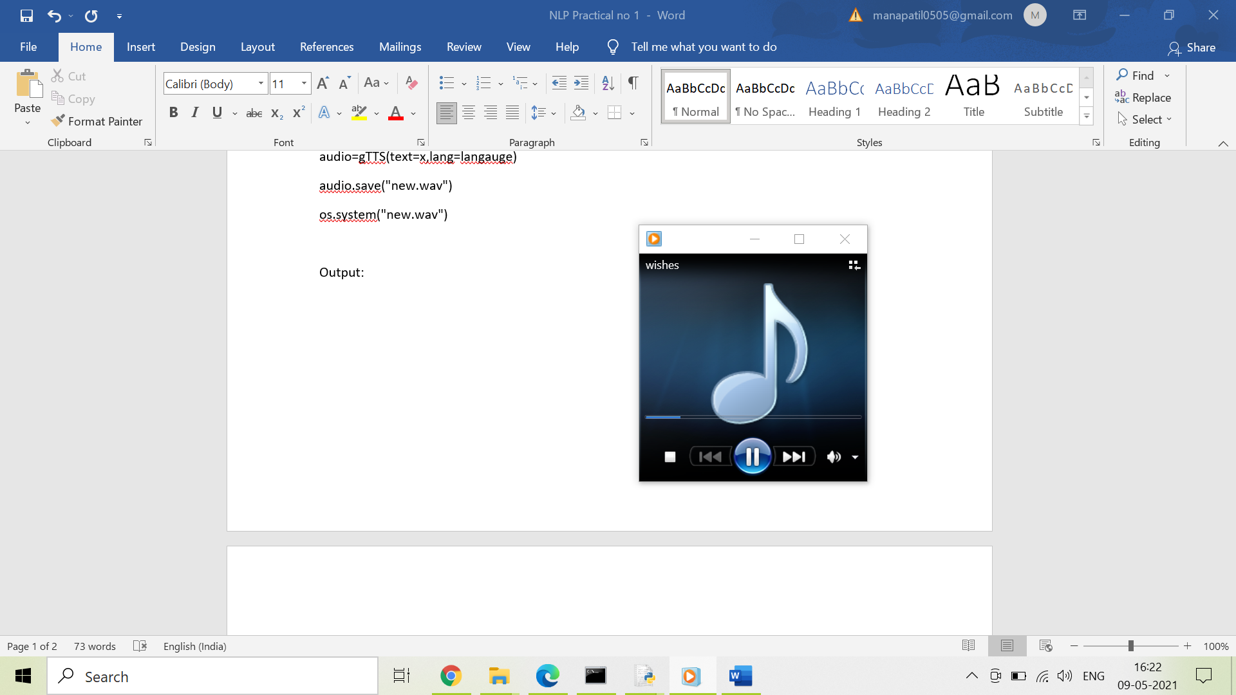

1. **Convert audio file Speech to Text.**

import speech_recognition as sr

filename = "Greetings.wav"

# initialize the recognizer

r = sr.Recognizer()

# open the file with sr.AudioFile(filename) as source:

# listen for the data (load audio to memory)

audio_data = r.record(source)

# recognize (convert from speech to text)

text = r.recognize_google(audio_data)

print(text)

Output:

